- There is at least one example of the model classes (Room, Customer, Reservation`) using data encapsulation.
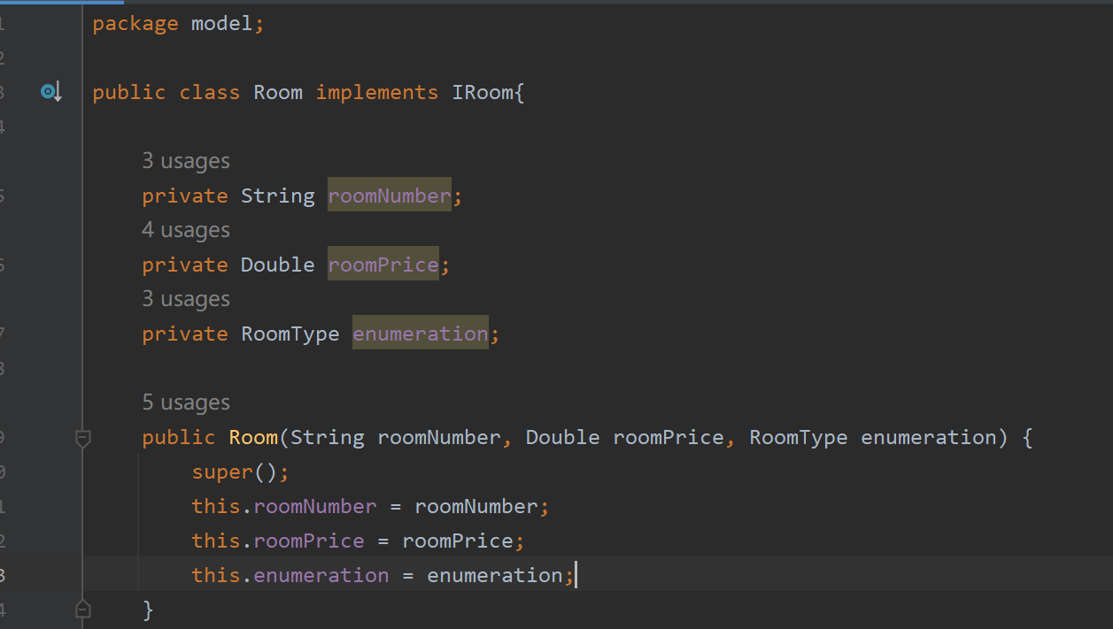
Reply: In the Room class, I have changed all variables into private access, if other class need to know the roomnumber or roomprice, use public getroomnumber() or public getroomprice()method instead.
- ⚠️ At least one example of the model classes Room, Customer, and Reservation overriding the equals and hashcode methods.
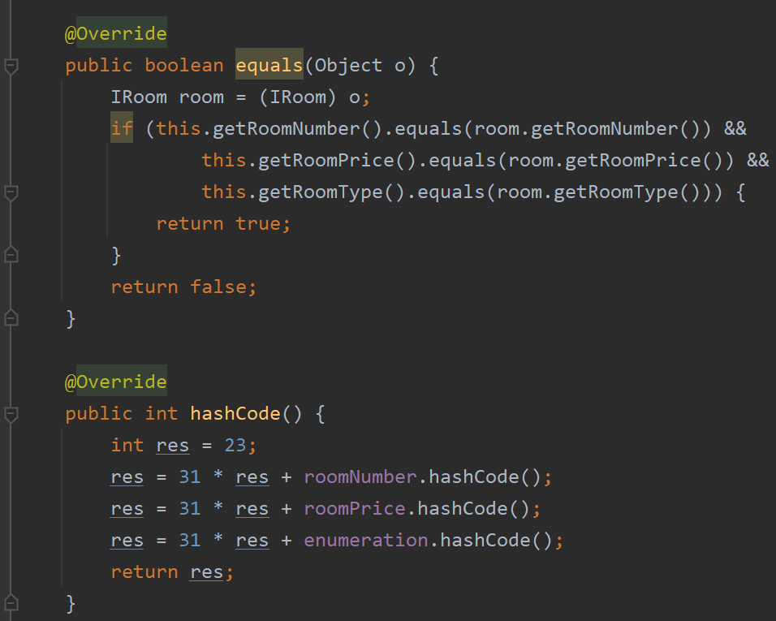
Reply: Have override equals(Object o) and hashCode() method in the Room class,

- ⚠️ Including the final access modifiers on your data model class variables.
Reply: Has revised as requested, the final access has been given to Double roomPrice in FreeRoom class .
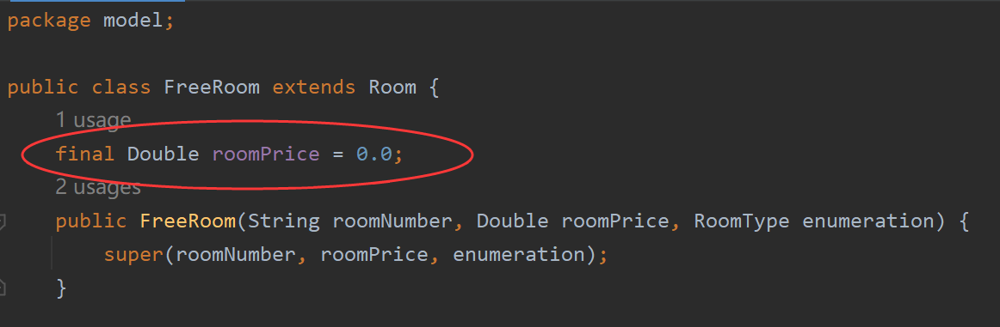

- ⚠️ Make sure that users can book the different room numbers on the same dates and don't allow the user to book the same room twice for the same dates.
Reply: Has revised as requested, before creating a reservation, will check if the room is available in the given date, if not, will notify the user room is not available and give recommend rooms.
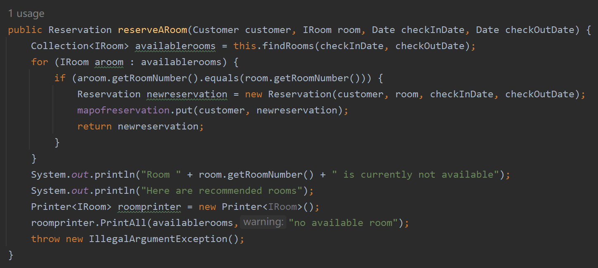
- ⚠️ Display the recommend rooms when all rooms are already booked for the hotel.
Reply: Has revised as requested, See reply 3.

- ⚠️ Make sure to use the default access method for the reservation service class.
The default access method for the reservation service class is added
Reply: A default class Printer<T> and default method PrintAll(Collection<T> c, String warning) are added in the reservation service class to deal with print operations methods such as print printAllRooms(), printAllReservatiuons() in the service package.
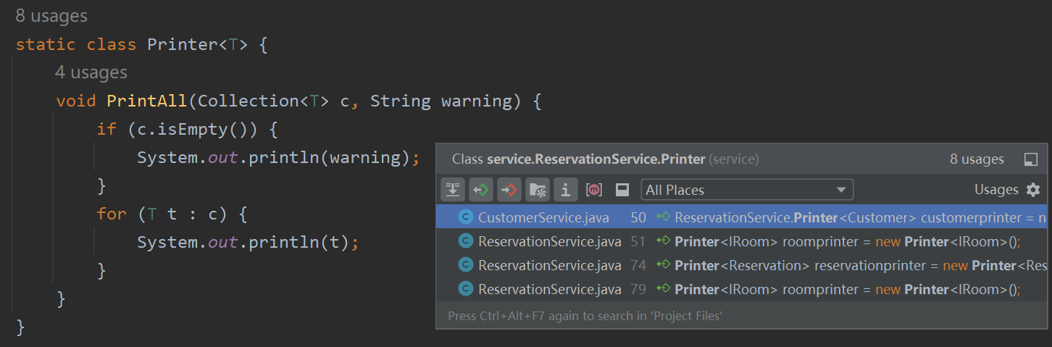

- ⚠️ The application UI uses a switch statement to handle the user input flow.
Reply: Has revised as requested, set switch statement in ui package.
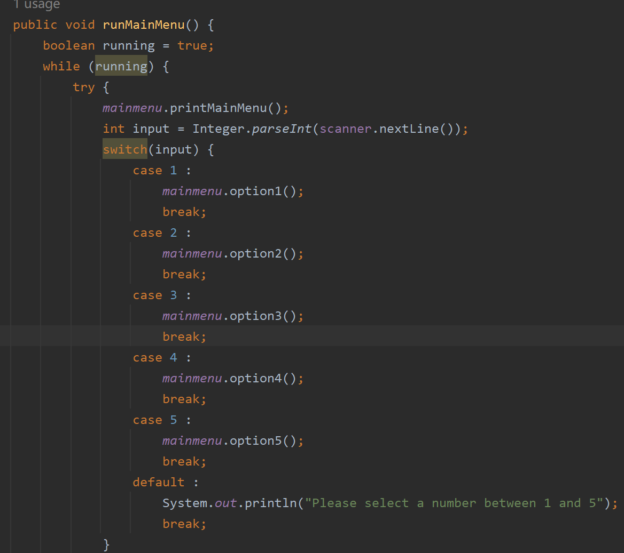

- The equalsIgnore() is adopted as suggested

